

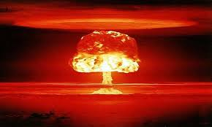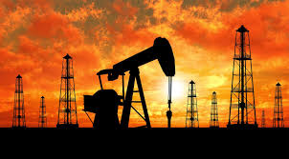

**____________________________________________________________________________**

**Oil**

1. What is the long-term price history of the key (root) commodity in question? • in nominal terms • adjusted for price inflation?

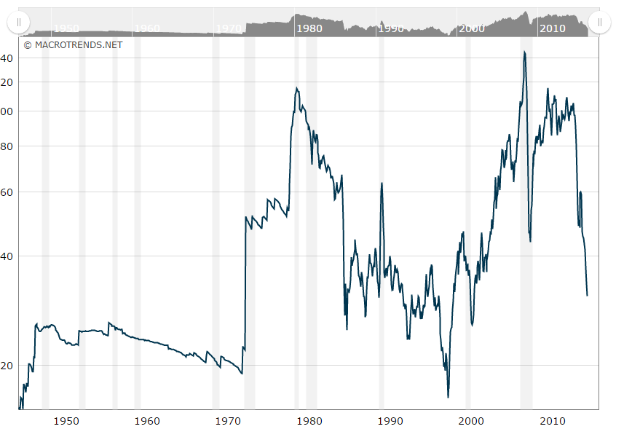

<http://www.macrotrends.net/1369/crude-oil-price-history-chart>

Very useful interactive graph, able to change time range. FINN also LIKES NUKES IN HIS BUTT

and has Nominal price.

2. What is the long-term price history of subsidiary commodities (such as distillates for crude oil), if

relevant?

3. What is the current breakdown of the use of the resource (demand)?

most of the crude oil produced and imported into the united states is Refined Usa consumed 6.97 billion barrels of petroleum products

global 96.4 million barrels a day

4. What is the current breakdown of the source of the resource (supply)?

97.07 million barrels per day

5. What is the historical breakdown of the use of the resource (demand)?

6. What is the historical breakdown of the source of the resource (supply)?

7. To the extent this can be determined, what is the KwH cost of using this resource in as many applications as you can determine?

5.8 million btu/per barrel * 0.00029307107017 kWh = approximately 1699.812 kWh

price/barrel

8. To the extent that this can be determined, what are the emissions effects of using this

resource?

Significant http://www3.epa.gov/air/tribal/pdfs/presentationpetroleumrefineries14Dec11.pdf

____________________________________________________________________________

**Nuclear**

1. What is the long-term price history of the key (root) commodity in question? • in nominal terms • adjusted for price inflation

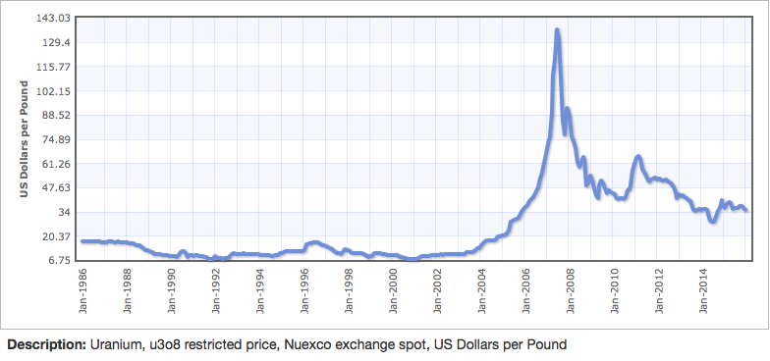

2. What is the long-term price history of subsidiary commodities (such as distillates for crude oil), if relevant?

3. What is the current breakdown of the use of the resource (demand)?

In the U.S. 19.5 percent of our energy comes from Nuclear power, with 797.1 billion kilowatt-hours generated in 2014 and expanding. Currently there are 5 1100 MWe nuclear reactors under construction in the U.S., and current power plants are being run at higher capacity and higher efficiency than ever before creating more power output. This means that more Uranium is being demanded for nuclear power than ever before in the United States.

4. What is the current breakdown of the source of the resource (supply)?

Currently, the United States source of Uranium has been coming from a select number of mines around the world as well as from the nuclear arsenal. Since 1987, the U.S. as well as other nations has been disarming nuclear weapons and using the enriched weapons grade Uranium which is up to 25% more concentrated than the Uranium needed for reactors to power nuclear reactors. In the year 2000, the disarmament of nuclear weapons proved 15% of the world’s supply of Uranium fuel for reactors.

5. What is the historical breakdown of the use of the resource (demand)?

After the atom bomb was created, the focus on nuclear energy turned from weaponry to energy to provide electricity and naval propulsion. Around 1956, reliable nuclear power plants were the main focus of designers. The demand for nuclear power was really only present in the US and Russia. It wasn’t until the 1960 that nuclear power became much more important as a power source. However, from 1970 to 2002, the nuclear power industry took a big hit (called the “nuclear power brown out”), which incidentally caused the price of Uranium to drop . Since then, nuclear power plants have been improved and the nuclear power industry is being revitalized.

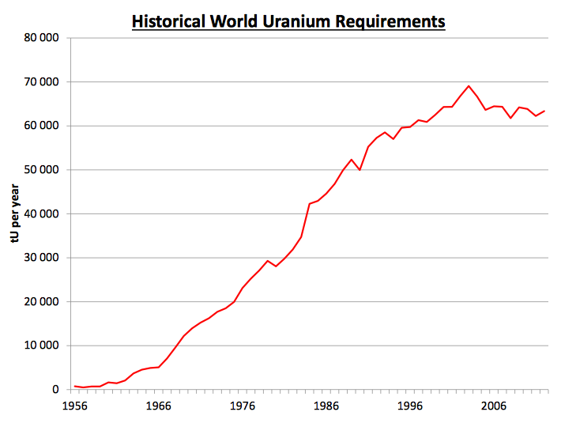

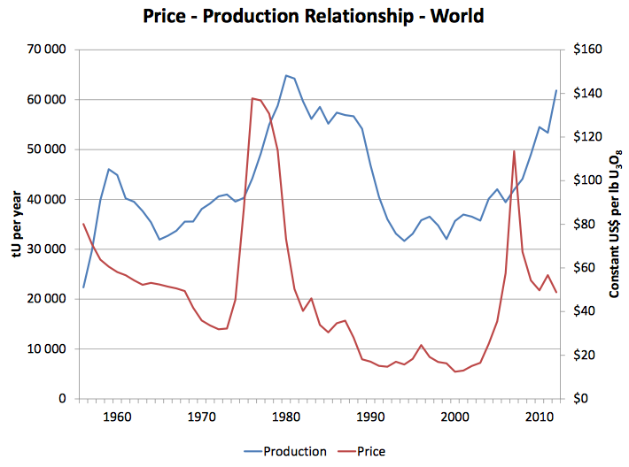

6. What is the historical breakdown of the source of the resource (supply)?

Because the U.S. imports their Uranium, it ties the U.S. nuclear energy market tightly to the supply of Uranium. For example, a flood of a Uranium mine in 2006 caused the price of Uranium to sky rocket nearly 700%. The concern with the supply of Uranium is much more volatile than other resources because Uranium is only mined by a few places in the world, therefore, the supply can be largely affected by outside factors.

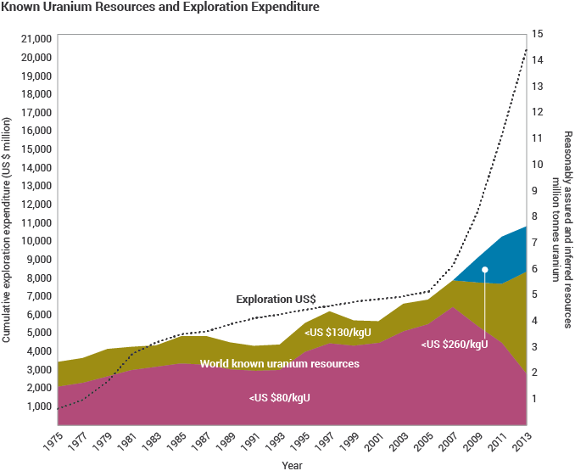

7. To the extent this can be determined, what is the KwH cost of using this resource in as many applications as you can determine?

Interestingly enough, the output of existing nuclear power plants has increased recently with no addition of nuclear power plants. Because of advances in technology, KwH outputs of nuclear power plants have increased phenomenally over the same plants life cycle. This is mostly attributed to the plants being run at higher capacity. For example, the same plant in the United States that ran at 56% capacity in 1980 now runs at 81% capacity in terms of uranium usage. This factors into our KwH cost because the increase in power output mitigates the overhead required for the original building of the infrastructure more so than when the plants ran at lower capacity. (1.)

8. To the extent that this can be determined, what are the emissions effects of using this resource? Marble disposal method?

There really aren’t any emissions to Nuclear power, adding a great advantage to nuclear power. However, of the main reasons it is less popular than other energy sources despite its non-emission is the severe hazards that arise from nuclear meltdowns and the inability to dispose of used up radioactive materials.

____________________________________________________________________________

**References:**

Uranium demand graph and Uranium price graph

<https://www.iaea.org/OurWork/ST/NE/NEFW/Technical-Areas/NFC/documents/uranium/tm-isl-2013/02.Pool_2013_U_supply_demand_prices.pdf>

Uranium supply graph:

1.<http://world-nuclear.org/information-library/current-and-future-generation/nuclear-power-in-the-world-today.aspx>

Uranium price history graph: <http://www.indexmundi.com/commodities/?commodity=uranium&months=360>

Nuclear Emissions

<http://www.nei.org/Issues-Policy/Protecting-the-Environment/Life-Cycle-Emissions-Analyses>

History of Nuclear Power

<http://world-nuclear.org/information-library/current-and-future-generation/outline-history-of-nuclear-energy.aspx>